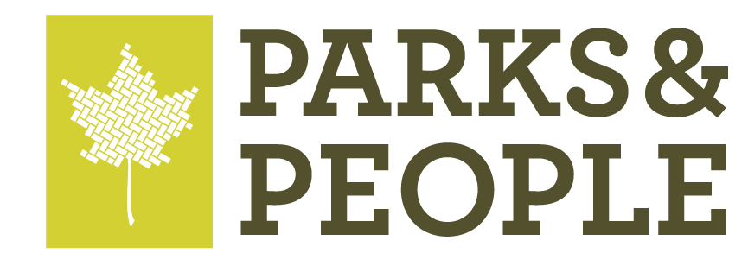

PR CONTACT:
Gabriel Carter
667-217-3045
gabriel.carter@parksandpeople.org

PRESS RELEASE February 14, 2024

Parks & People and South Baltimore Gateway Partnership Seek Community Input on Future Baltimore Black Sox Baseball Team Memorial

BALTIMORE, Md.– Parks & People (P&P), in collaboration with the South Baltimore Gateway Partnership (SBGP), is advancing the community outreach and engagement phase of the exciting Baltimore Black Sox Team Memorial project. This initiative aims to establish a memorial to commemorate the remarkable legacy of the Baltimore Black Sox Negro League Baseball team while celebrating the resilience of diverse communities in Baltimore.

P&P’s project management team, led by Site Insight and Mayson Dixon, is communicating with local neighborhood associations, community leaders, and residents to solicit feedback through an online survey to learn about community priorities before the initial design concept of the memorial takes shape. The project management team is also attending local community meetings in-person and online to raise awareness of the survey and gain significant insight ahead of the design process.

Part of this robust community engagement strategy includes collaboration with Historically Black Colleges & Universities (HBCUs). During Phase 1, Parks & People is partnering with Coppin State University students to participate in a paid, credited program focused on researching Black Sox players and team owners. Coppin State University History Professor Dr. Dupree-Wilson shared, “This is an amazing opportunity for our students. We are delighted to partner with Parks & People to advance our History Program’s commitment to developing and training future Public Historians and Museum Professionals.”

The Baltimore Black Sox Memorial will be a prominent feature along a new African American Heritage Trail, symbolizing the indelible legacy of the Baltimore Black Sox and their profound influence on the city’s African American history and baseball culture. This trail is an important facet of the Reimagine Middle Branch Plan’s framework for Equitable Development to honor and celebrate African American culture through the creation of a heritage district.

Reimagine Middle Branch is a community-driven initiative led by the City of Baltimore, South Baltimore Gateway Partnership, and Parks & People, working alongside a team of expert consultants, stakeholders, HBCU faculty and students, and Baltimoreans.

For more information or to complete the project’s community survey, visit https://bit.ly/blacksoxmemorial.

Black Sox social media: Instagram | Facebook

About Parks & People
Founded in 1984, Parks & People (P&P) is dedicated to improving Baltimore's communities through its commitment to green spaces and education. P&P’s initiatives, ranging from developing parks to sponsoring youth programs, aim to transform Baltimore's green spaces into vibrant hubs of activity and learning. To learn more about our mission or get involved, visit www.parksandpeople.org.

About South Baltimore Gateway Partnership
The South Baltimore Gateway Partnership was established in 2016 to help implement the South Baltimore Gateway Master Plan, a sweeping plan to improve neighborhoods near the Horseshoe Casino Baltimore, with funding provided by the Local Impact Grants generated by video lottery terminals. Under its Strategic Plan, SBGP works to improve the vitality of its communities by focusing on three crucial elements of the South Baltimore Gateway Master Plan: Community Development and Revitalization, Environmental Sustainability, and Health and Wellness. To achieve the agenda laid out in the Strategic Plan, SBGP has established three interrelated program areas: Community Grants, Enhanced Services, and Transformational Projects. To learn more visit www.sbgpartnership.org

